Automotive Sales & Market Analysis Report
An End-to-End Data Analytics Project covering Python EDA, Power BI Visualization, and Strategic Insights.
NAME= prince yadav

SUMMARY
This comprehensive project analyzes used car listings and vehicle market data from a large-scale automotive dataset comprising 371,528 records [cite: 5]. The primary objective is to evaluate listing attributes, vehicle pricing trends, regional availability, and vehicle conditions to guide pricing strategies, inventory management, and marketing decisions. By leveraging Python for data cleansing and feature engineering alongside Power BI for visualization, this report provides deep actionable intelligence into the used automobile market.

1. DATA SUMMARY
The raw dataset contained extensive transactional and descriptive attributes regarding used vehicle listings. Key structural properties include:
- Total Records: 371,528 vehicle entries [cite: 5].
- Key Features: Listing details (dateCrawled, name, seller, offerType, price, abtest), vehicle specs (vehicleType, yearOfRegistration, gearbox, powerPS, model, kilometer, fuelType, brand), and condition/location attributes (notRepairedDamage, postalCode, dateCreated, lastSeen).
- Data Quality Assessment: Initial inspection revealed missing values across critical categories such as vehicleType (37,869 missing), gearbox (20,209 missing), model (20,484 missing), fuelType (33,386 missing), and notRepairedDamage (72,060 missing). Redundant or constant columns like nrOfPictures (all zeros) were identified.

2. EDA USING PYTHON
Data preparation, cleansing, and feature engineering were executed systematically in Python:
- Data Type Conversion: Crawled, created, and last-seen timestamps were successfully parsed into proper datetime objects.
- Handling Missing Values & Standardization:
  - German damage indicators (ja / nein) were standardized to English (yes / no) [cite: 5].
  - Missing fuelType values were imputed using statistical mode [cite: 5].
  - The redundant nrOfPictures column was dropped [cite: 5].
  - Rows containing missing vehicleType, gearbox, and model values were cleaned to maintain model integrity [cite: 5].
- Feature Engineering: A new feature, vehicle_age, was calculated based on the registration year and current baseline (2026 - yearOfRegistration) to evaluate depreciation and pricing impact [cite: 5].
- Export: The fully sanitized dataset was saved as cleaned_autos1.csv for downstream dashboard integration [cite: 5].

3. DASHBOARD IN POWER BI (AUTOS DASHBOARD)
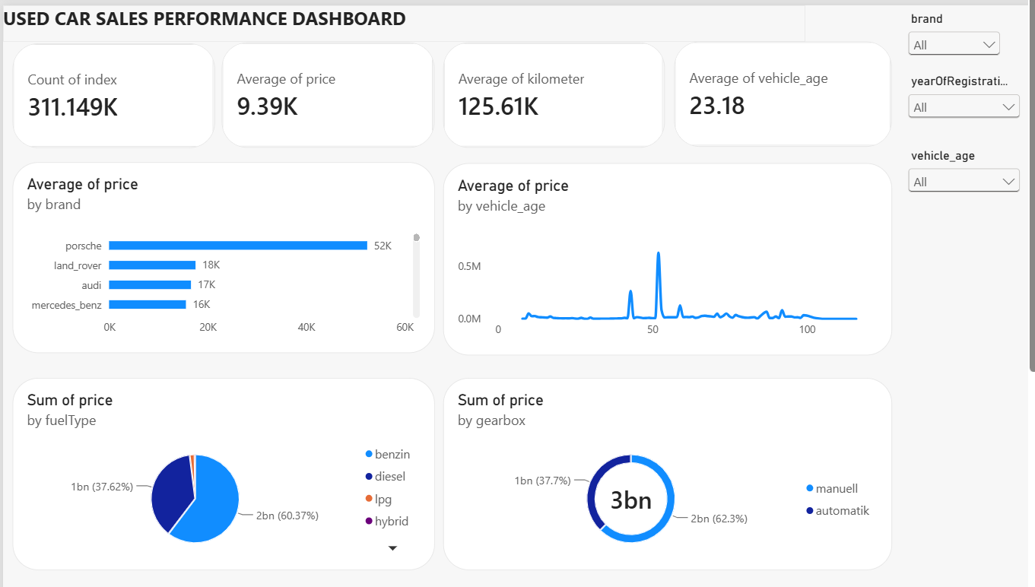
An interactive Power BI reporting workspace (autos_dashboard.pbip) was structured to visualize market dynamics [cite: 4, 5]:
- KPI Summary Cards: Total Listings, Average Vehicle Price, Average Mileage, and Total Active Brands.
- Visualizations:
  - Distribution of vehicle prices across popular brands (Volkswagen, BMW, Audi, Mercedes-Benz).
  - Vehicle count and price distribution by vehicleType (limousine, kleinwagen, kombi, bus, coupe, suv).
  - Correlation analysis between vehicle mileage (kilometer), power (powerPS), and listing price.
  - Gearbox distribution (Manual vs. Automatic transmissions).
- Interactive Filtering: Dynamic slicers allowing deep dives into specific brands, fuel types, and damage status.

4. CONCLUSION
This analytics project demonstrates a complete end-to-end data workflow—from raw data ingestion and rigorous cleaning in Pandas to interactive business intelligence reporting in Power BI. The insights generated enable buyers and sellers to make data-driven pricing decisions, optimize inventory turnover, and understand the core determinants of used vehicle valuation in the European market.

